Project Design Phase-II
Data Flow Diagram & User Stories

Date | 29 June 2026
Team ID
Project Name | India's Agricultural Crop Production Analysis
Maximum Marks | 4 Marks

Data Flow Diagrams:
A Data Flow Diagram (DFD) is a traditional visual representation of the information flows within a system. A neat and clear DFD can depict the right amount of the system requirement graphically. It shows how data enters and leaves the system, what changes the information, and where data is stored.
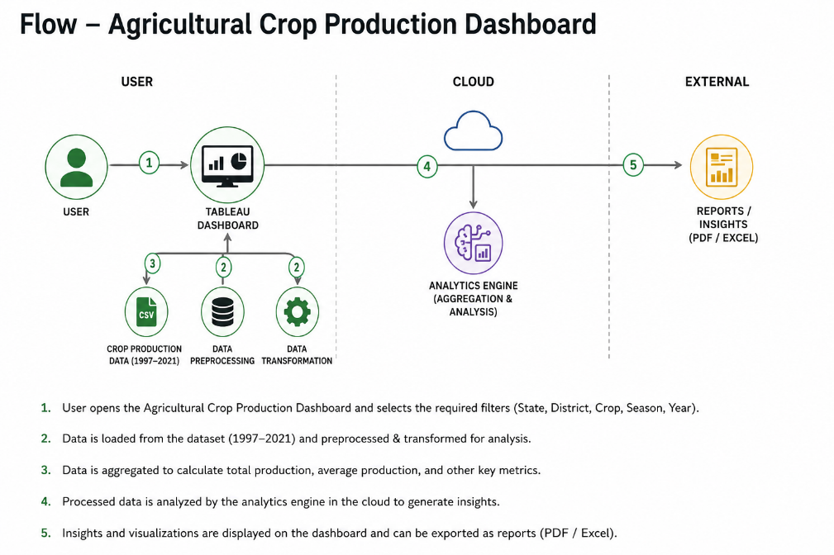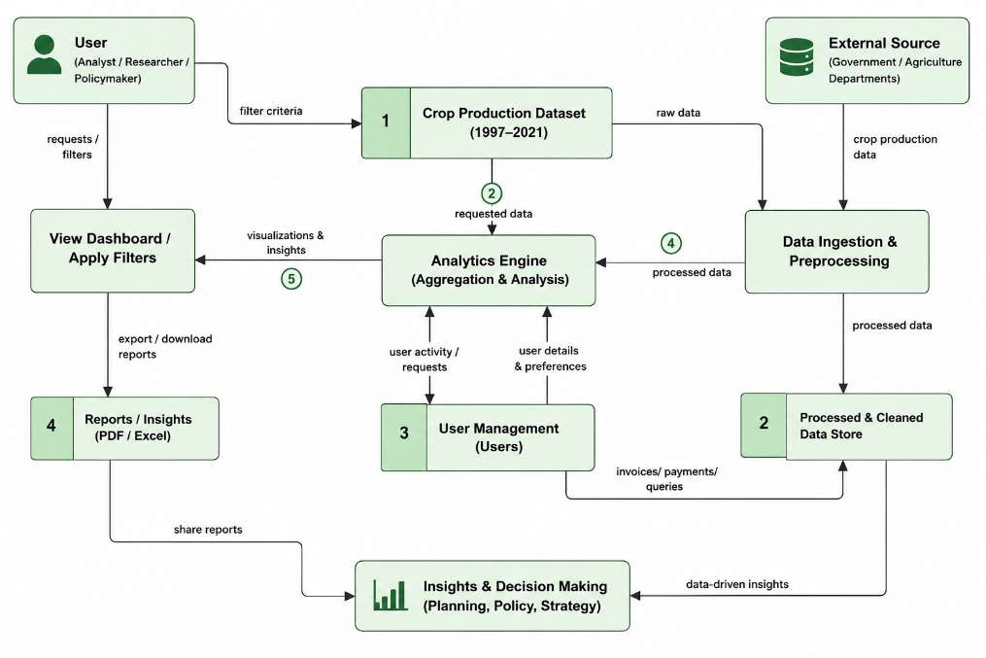

User Stories
User Type | Functional Requirement (Epic) | User Story Number | User Story / Task | Acceptance criteria | Priority | Release
Customer (Mobile user) | Dashboard Access | USN-1 | As a user, I can register for the application by entering my email, password, and confirming my password. | Dashboard opens successfully. | High | Sprint-1
Customer |  | USN-2 | As a user, I will receive confirmation email once I have registered for the application | I can receive confirmation email & click confirm | High | Sprint-1
Customer |  | USN-3 | As a user, I can register for the application through Facebook | I can register & access the dashboard with Facebook Login | Low | Sprint-2
Customer |  | USN-4 | As a user, I can register for the application through Gmail |  | Medium | Sprint-1
 | Login | USN-5 | As a user, I can log into the application by entering email & password |  | High | Sprint-1
 | Dashboard
Customer (Web user) | Story Analysis | USN-6 | As a user, I can view Tableau Story insights for better understanding. | Story pages display correctly. | Medium | Sprint-2
Customer Care Executive | Data Management | USN-7 | As an administrator, I can update the agricultural dataset. | Updated data is reflected in the dashboard. | High | Sprint-2
Administrator | Report Sharing | USN-8 | As an administrator, I can export dashboard reports. | Reports are downloaded successfully. | Medium | Sprint-2

